Name of Student: Aniruddha Pratap Singh | PRN:25070122247
Semester: III | Year : AY 2026-27
Subject: Programming with Java
ASSIGNMENT No : 5
TITLE : Collection Classes and StringBuffer
Problem Statement
Develop a Java application demonstrating the use of ArrayList, Vector, and StringBuffer for dynamic data storage, management, and string manipulation.
Learning Objectives
To implement dynamic data storage and string manipulation using ArrayList, Vector, and StringBuffer.

Programme
import java.util.ArrayList;
import java.util.Scanner;

public class merged {

public static void main(String[] args) {

ArrayList<String> tasks = new ArrayList<>();

// Predefined learning tasks
tasks.add("Read about the discovery of nuclear fission.");
tasks.add("Learn the difference between fission and fusion.");
tasks.add("Study the strsucture of an atom.");
tasks.add("Watch a documentary on nuclear energy.");
tasks.add("Read about radiation safety.");
tasks.add("Learn the peaceful uses of nuclear technology.");

Scanner sc = new Scanner(System.in);

int choice;

do {

System.out.println("\n========== LEARNING PLANNER ==========");
System.out.println("1. View Today's Learning Tasks");
System.out.println("2. Add New Learning Task");
System.out.println("3. Remove Completed Task");
System.out.println("4. Exit");
System.out.print("Enter your choice: ");

choice = sc.nextInt();
sc.nextLine();

switch (choice) {

case 1:

if (tasks.isEmpty()) {
System.out.println("No tasks available.");
} else {

StringBuffer sb = new StringBuffer();

sb.append("\n===== TODAY'S LEARNING PLAN =====\n\n");

for (int i = 0; i < tasks.size(); i++) {
sb.append((i + 1) + ". " + tasks.get(i) + "\n");
}

System.out.println(sb);
}

break;

case 2:

System.out.print("Enter New Learning Task: ");
String newTask = sc.nextLine();

tasks.add(newTask);

System.out.println("Task Added Successfully.");

break;

case 3:

if (tasks.isEmpty()) {
System.out.println("No tasks available to remove.");
} else {

System.out.println("\nCurrent Tasks:");

for (int i = 0; i < tasks.size(); i++) {
System.out.println((i + 1) + ". " + tasks.get(i));
}

System.out.print("Enter task number to remove: ");

int remove = sc.nextInt();

if (remove >= 1 && remove <= tasks.size()) {

tasks.remove(remove - 1);

System.out.println("Task Removed Successfully.");

} else {

System.out.println("Invalid Task Number.");

}

}

break;

case 4:

System.out.println("Thank You!");

break;

default:

System.out.println("Invalid Choice.");

}

} while (choice != 4);

sc.close();

}
}

Output
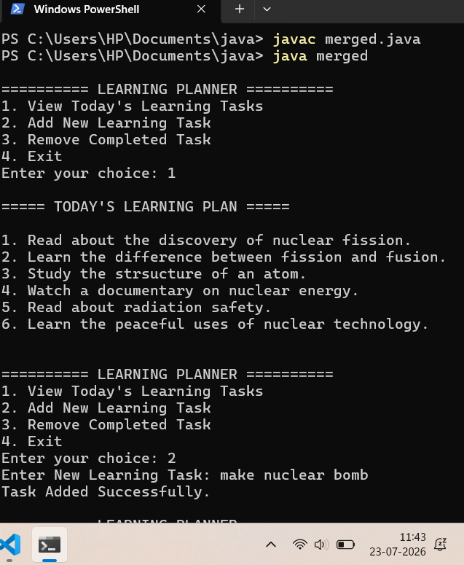
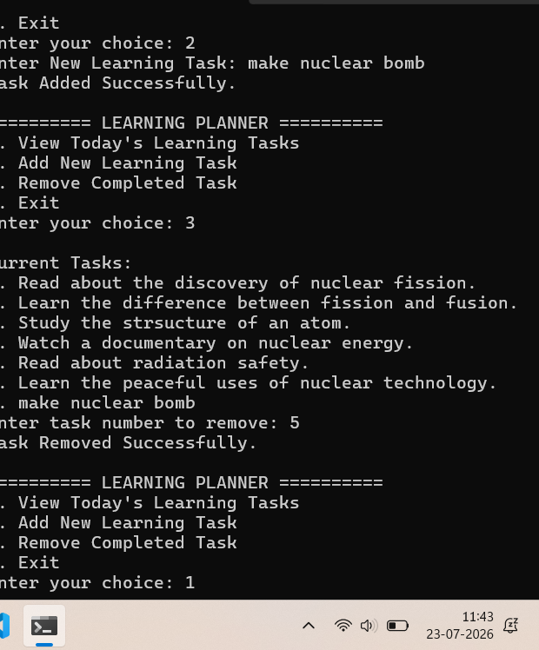
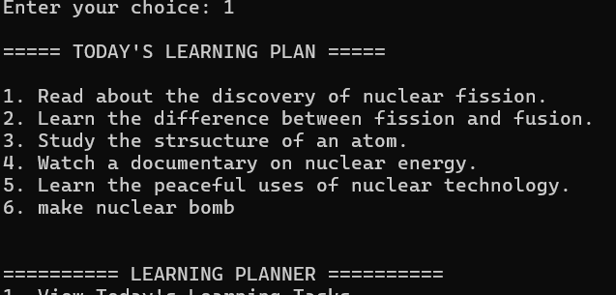

Exercise 1
Create a To-Do List application using ArrayList to store tasks and StringBuffer to display tasks

Source code:

import java.util.ArrayList;
import java.util.Scanner;

public class TodoList {

public static void main(String[] args) {

ArrayList<String> todo = new ArrayList<>();
Scanner input = new Scanner(System.in);

int choice;

do {

System.out.println("\n========== TO-DO LIST ==========");
System.out.println("1. Add Task");
System.out.println("2. Remove Task");
System.out.println("3. Display Tasks");
System.out.println("4. Exit");
System.out.print("Choose an option: ");

choice = input.nextInt();
input.nextLine();

switch(choice) {

case 1:

System.out.print("Enter Task: ");
String task = input.nextLine();

todo.add(task);

System.out.println("Task Added Successfully.");
break;

case 2:

if(todo.isEmpty()) {

System.out.println("Task List is Empty.");

} else {

System.out.println("Current Tasks:");

for(int i=0;i<todo.size();i++) {

System.out.println((i+1)+". "+todo.get(i));

}

System.out.print("Enter Task Number to Remove: ");

int remove = input.nextInt();

if(remove>=1 && remove<=todo.size()) {

todo.remove(remove-1);

System.out.println("Task Removed Successfully.");

}

else {

System.out.println("Invalid Task Number.");

}

}

break;

case 3:

StringBuffer sb = new StringBuffer();

sb.append("\n------ MY TO-DO LIST ------\n");

if(todo.isEmpty()) {

sb.append("No Tasks Available.\n");

}

else {

for(int i=0;i<todo.size();i++) {

sb.append((i+1)+". "+todo.get(i)+"\n");

}

}

System.out.println(sb);

break;

case 4:

System.out.println("Closing Application...");
break;

default:

System.out.println("Invalid Choice.");

}

}while(choice!=4);

input.close();

}

}
Output:
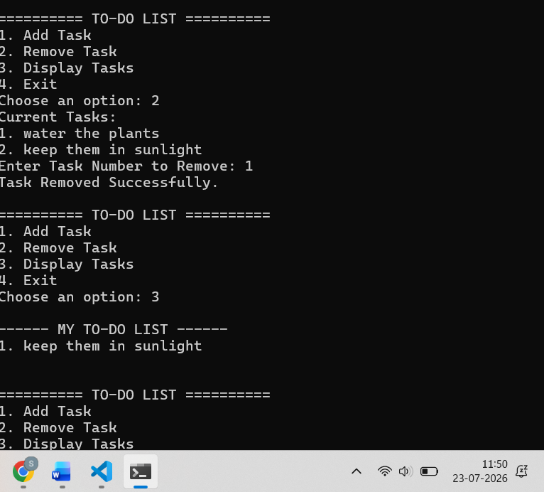

2. Create a Student Course Registration System using ArrayList to store the list of courses registered by a student and StringBuffer to generate and display the registered course list. The application should allow users to add, remove, and view registered courses.

Source code:

import java.util.ArrayList;
import java.util.Scanner;

public class CourseRegistration {

public static void main(String[] args) {

ArrayList<String> registeredCourses = new ArrayList<>();

Scanner input = new Scanner(System.in);

int option;

do {

System.out.println("\n===== COURSE REGISTRATION =====");
System.out.println("1. Register Course");
System.out.println("2. Drop Course");
System.out.println("3. View Registered Courses");
System.out.println("4. Exit");
System.out.print("Enter Choice: ");

option = input.nextInt();
input.nextLine();

switch(option) {

case 1:

System.out.print("Enter Course Name: ");

String course = input.nextLine();

registeredCourses.add(course);

System.out.println("Course Registered Successfully.");

break;

case 2:

if(registeredCourses.isEmpty()) {

System.out.println("No Registered Courses.");

}

else {

System.out.println("Registered Courses:");

for(int i=0;i<registeredCourses.size();i++) {

System.out.println((i+1)+". "+registeredCourses.get(i));

}

System.out.print("Enter Course Number to Remove: ");

int remove = input.nextInt();

if(remove>=1 && remove<=registeredCourses.size()) {

registeredCourses.remove(remove-1);

System.out.println("Course Removed Successfully.");

}

else {

System.out.println("Invalid Choice.");

}

}

break;

case 3:

StringBuffer sb = new StringBuffer();

sb.append("\n----- REGISTERED COURSES -----\n");

if(registeredCourses.isEmpty()) {

sb.append("No Courses Registered.\n");

}

else {

for(int i=0;i<registeredCourses.size();i++) {

sb.append((i+1)+". "+registeredCourses.get(i)+"\n");

}

}

System.out.println(sb);

break;

case 4:

System.out.println("Thank You!");
break;

default:

System.out.println("Invalid Option.");

}

}while(option!=4);

input.close();

}

}

Output:

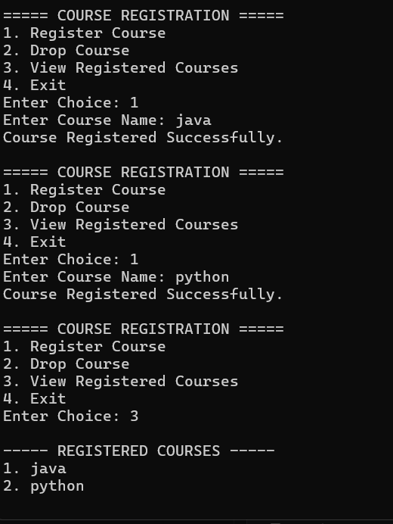
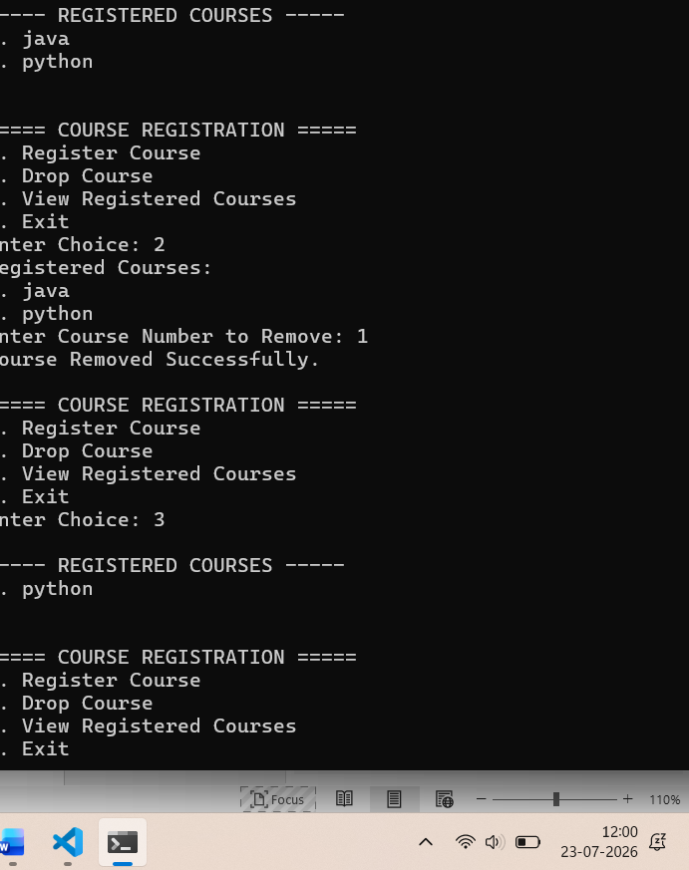

Conclusion
Conclusion :

The assignment demonstrated the use of ArrayList for dynamic data management and StringBuffer for string manipulation. It enhanced the understanding of Java collections and their application in developing efficient and flexible programs.

